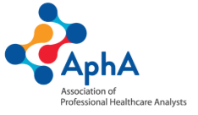



Annual Report
2025/26
Foreword
As Co-Chief Executive Officers and President of the Association of Professional Healthcare Analysts (AphA), we are proud to introduce this year’s Annual Report, reflecting a period of meaningful progress, growing influence, and collective achievement.
Throughout 2025/26, AphA has continued to evolve as the professional home for health & care data and analytics across the UK. From strengthening our learning and development offer, to expanding our networks and deepening our national engagement, this has been a year defined by ambition, adaptability, and delivery. We have not only achieved a significant proportion of our strategic objectives, but have also responded positively to a rapidly changing external landscape, particularly in relation to professional registration and national workforce developments.
None of this progress would have been possible without the energy, expertise and commitment of our members. Whether through leading networks, contributing to events, shaping professional standards, or supporting one another, our community remains at the heart of AphA’s success. It is this collective spirit that continues to drive our organisation forward.
As we look ahead, we do so with confidence. The foundations established this year position us strongly for the future - to further enhance our professional offer, increase our influence, and continue advocating for the vital role of health and care data and analytical professionals in improving health and care outcomes.
Together, we will build on this momentum and ensure AphA remains a dynamic, inclusive, and impactful professional body for years to come.

Jane Sonia Emma

Jane Johnston Sonia Patel Emma Wright
Co-CEO President Co-CEO
Executive Summary
This year has marked a period of substantial progress for the Association of Professional Healthcare Analysts (AphA), as the organisation strengthened its professional infrastructure, delivered key strategic objectives, and reinforced its role as the leading professional body for healthcare analysts.
A three-year strategy was approved by the AphA Board, with priorities across five strategic domains:
- Learning & Development
- Professional Registration
- Advocacy
- Organisational Sustainability
- Advisory Services
Each strategic domain included a number of objectives, and the organisation achieved a high proportion of its planned deliverables, while also adapting to significant national developments in workforce and professional standards.
AphA successfully launched and embedded several high-value professional networks, including the Population Health Management and Clinical Coding Leaders’ Networks, each of which achieved strong early engagement and national visibility. Our commitment to learning and development continued with the full establishment of the Lunch & Learn programme and ongoing delivery of the mentorship scheme.
A major external shift occurred with the Federation for Informatics Professionals (FEDIP) proposal to NHS England concerning the requirement for professional registration for data and analytics professionals. With NHSE support confirmed, AphA’s internal roadmap work for professional registration was superseded, enabling alignment with a unified national approach to professional standards.
Engagement with senior digital and data leaders across the four nations also advanced, with notable progress in Scotland with the re-establishment of the Scottish branch. Engagement with both Wales, and Northern Ireland has continued through complementary FEDIP activity.
The organisation strengthened its financial and operational sustainability through the establishment of a commercial function that has enabled income-generation capability and the attraction of sponsorship. This has and will continue to enable the organisation to maintain low membership fees and invest in member development, which has included conferences and bursaries.
AphA now enters 2026 with a solid platform for growth, enhanced reputation, and a strengthened ability to advocate for the data and analytics profession across the UK.
Summary
This Annual Report provides a comprehensive overview of AphA’s progress against its strategic objectives for the 2025/26 financial year, with a final status position as of January 2026. We have delivered objectives across all our strategic priority areas of Learning & Development, Professional Registration, Advocacy, Organisational Sustainability, and Advisory Services
AphA has continued to strengthen its professional offer, expand its national influence, and demonstrate tangible value to members.
Despite an unstable and dynamic national landscape in data and analytics in England, AphA delivered a significant number of objectives to completion and laid strong foundations for 2026, particularly through the expansion of specialist networks, professional engagement with UK nations, and increased organisational capability.
Like all strategies, our three-year plan has been subject to changes due to opportunities and changes within the wider health and care environment. Two examples of where we have pivoted our direction of travel are Professional Registration and Advisory Services.
Our ambitions to develop a roadmap for the increase of professional registration has been paused during this year while AphA awaited the outcome of proposals from the Federation for Informatics Professionals (FEDIP) to NHS England in relation to membership of professional bodies and professional registration. FEDIP is the home of the professional register and is made up of professional membership bodies, including AphA. This proposal represented all professional bodies within the FEDIP family, including AphA. The proposal has been accepted by NHS England and our own objective to deliver in this area will now be reviewed as we seek to onboard new members and deliver increased professional registration with an initial focus on senior roles.
Similarly, AphA had a strategic ambition to develop advisory services, with options to explore a separate arm of AphA to deliver services for income generation to ensure the membership organisation remained separate. An opportunity to partner with the emerging Data Observatory has again enable the AphA Board to review our own ambition and look to deliver this in partnership with the Data Observatory.
The following sections detail the deliverables that we expected to achieve during 2025/26 for each strategic theme. These are categorised to show which have been delivered, which will be carried forward to next year’s plans and those where we have reviewed and changed our strategic direction in reaction to other external opportunities.

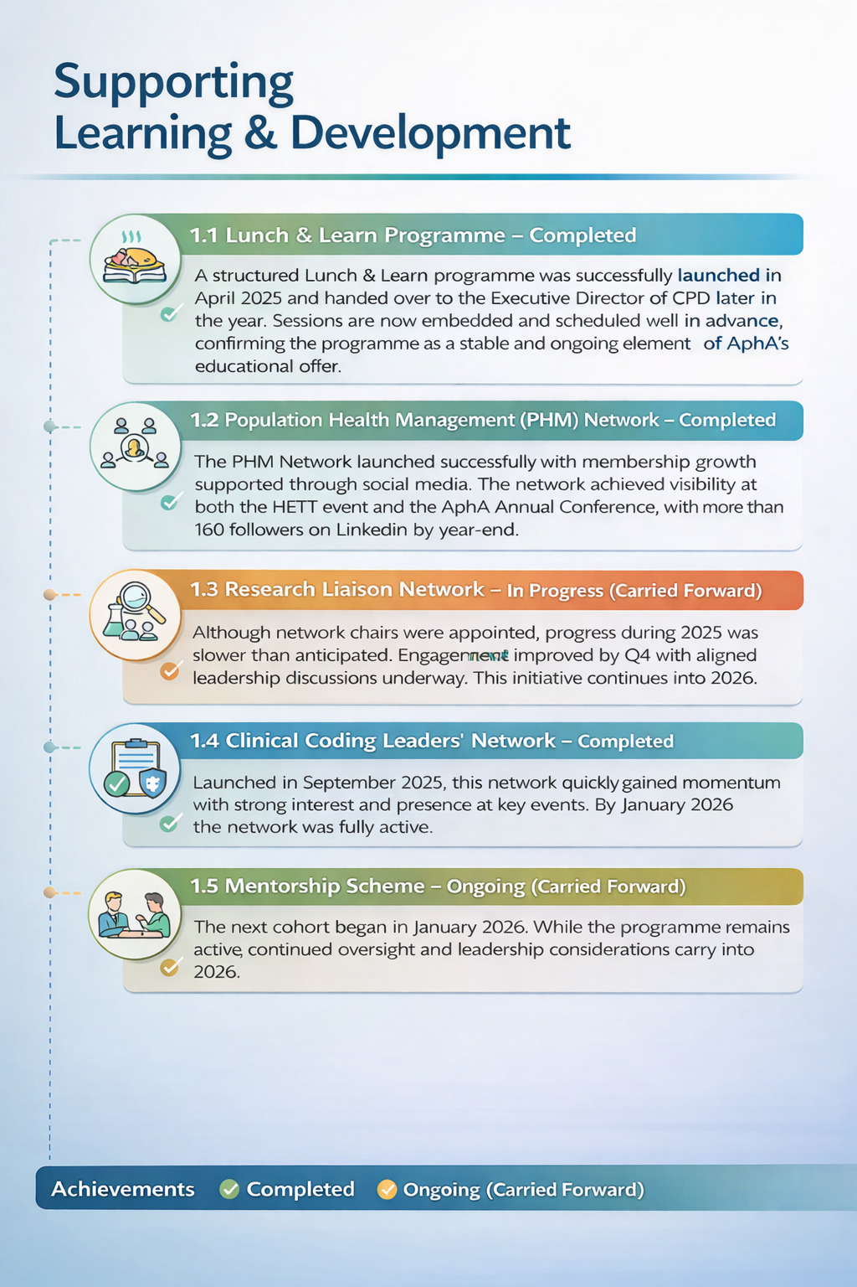
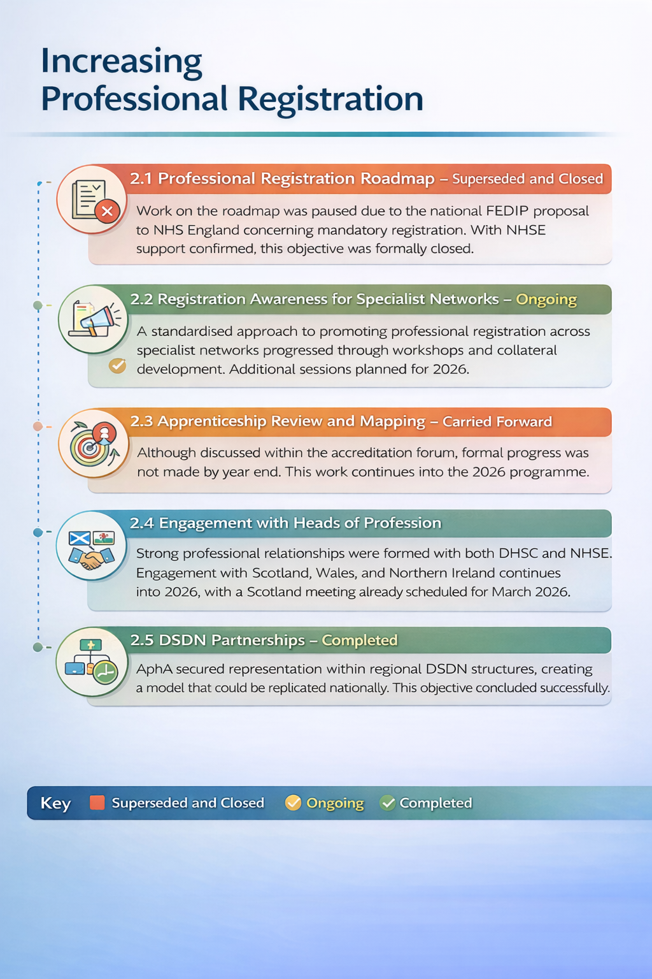
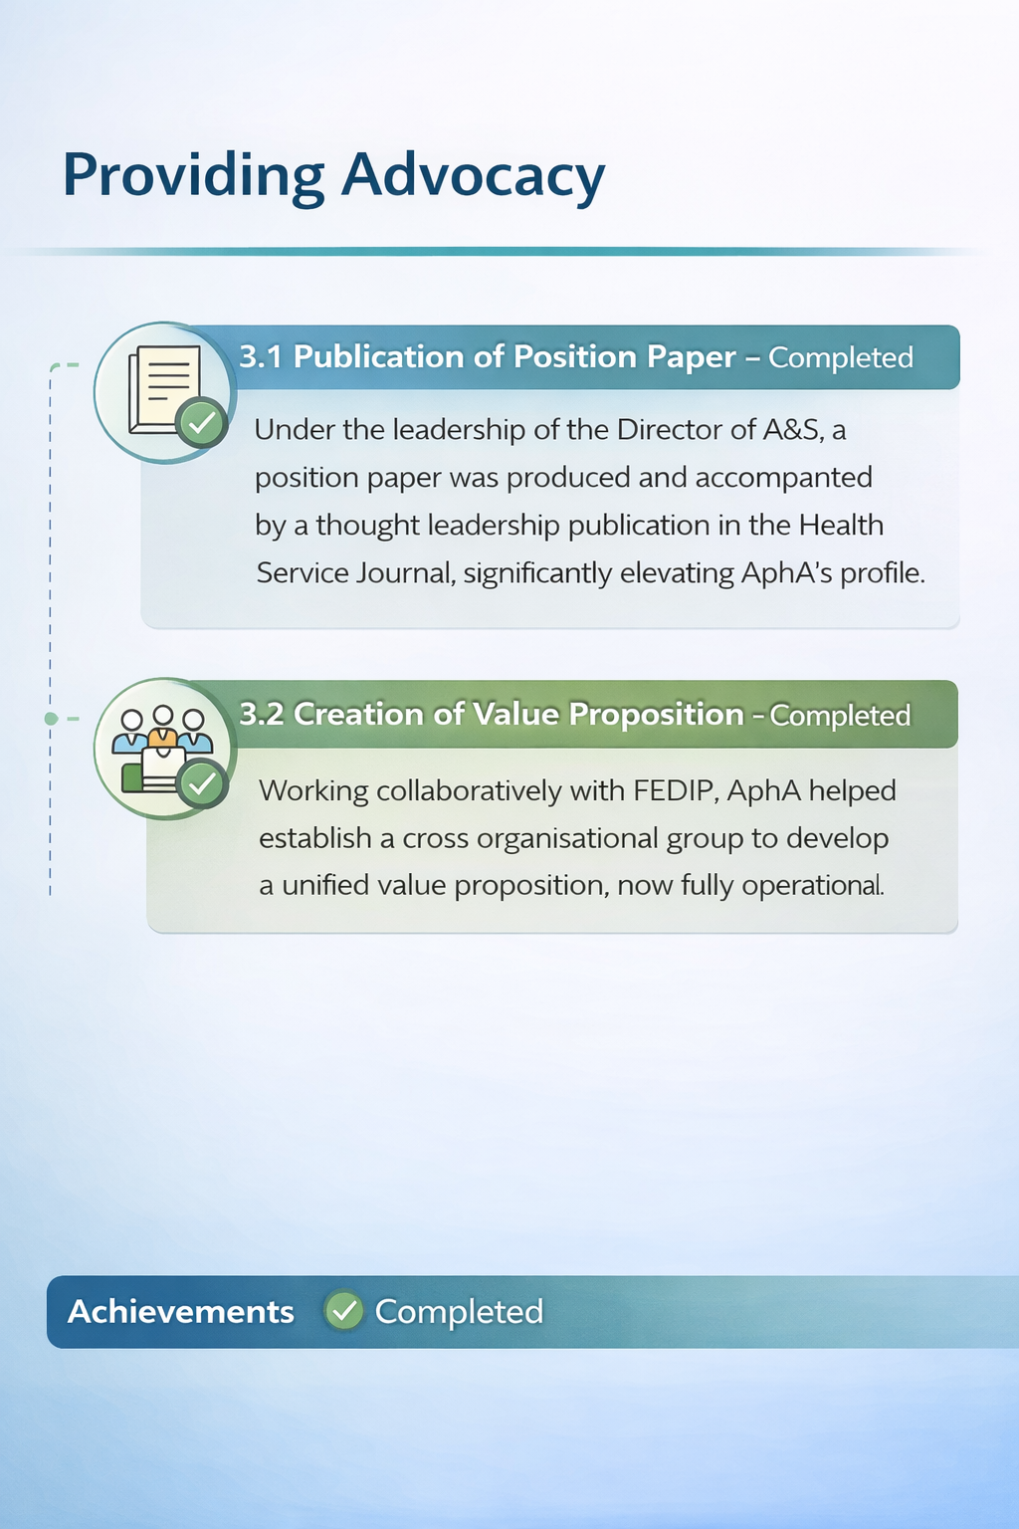
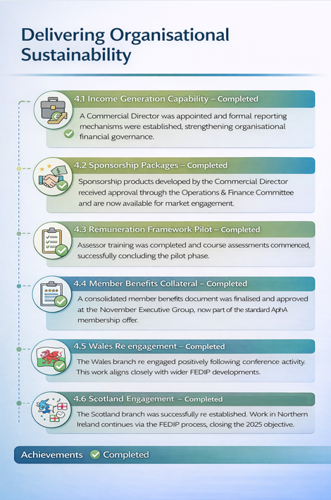


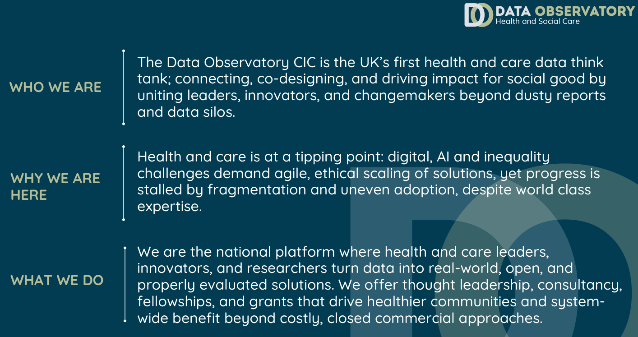
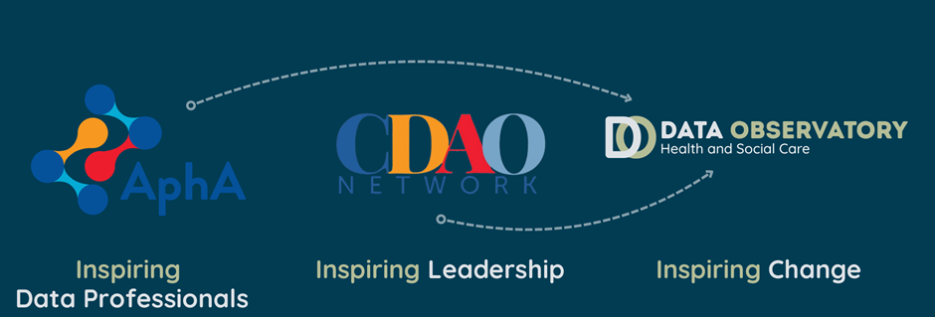
Our Year in Numbers….
As data and analytics professionals, it would be remiss of us not to try to capture our year in numbers!
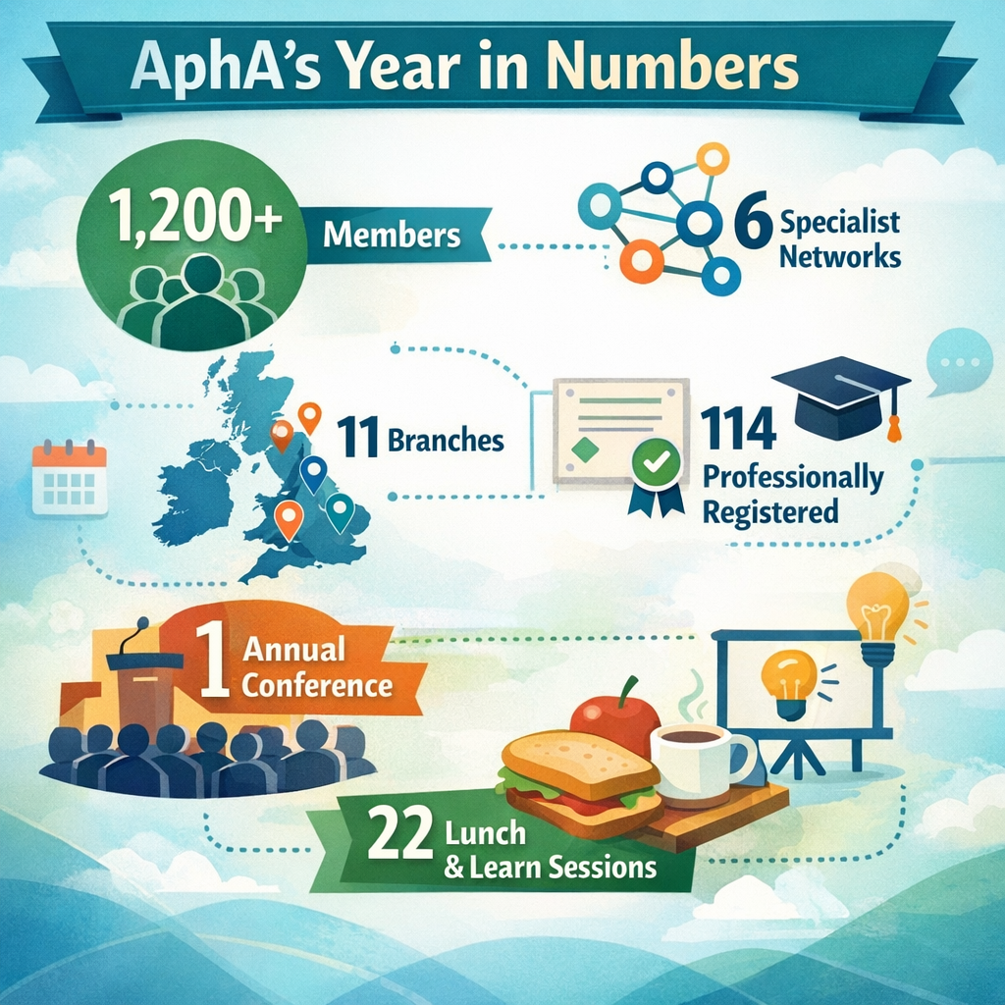
A Look Ahead….
We have laid some great foundations over the last twelve months, including our first strategy for the organisation. That strategy will now move us forward into 2026/27, with a further set of ambitions to increase the reach and influence of our organisation.
We had already established a set of objectives within our strategy, and we will look to deliver these, review our direction and ensure we continue to move forward with the interests of our members at the heart of everything we do.

Appendix A – Annual Accounts

